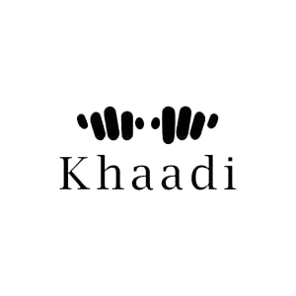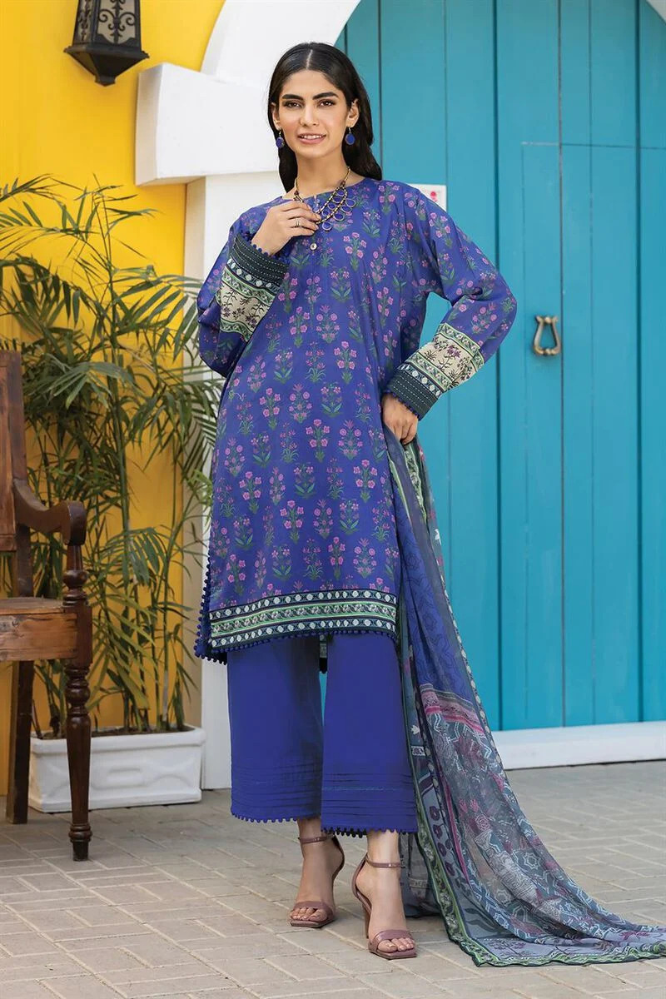­­­­

Lawn fabric is a popular choice for the shirt due to its lightweight and breathable nature, making it suitable for the country's warm climate. It is a finely woven cotton fabric that provides comfort and ease of move Completing the ensemble is the dupatta, a long scarf that is draped over the shoulders or around the neck. It adds an elegant touch to the outfit and can be used for both style and practical purposes. The dupatta can also feature matching prints or contrasting designs, enhancing the overall aesthetic appeal.

The three-piece dress you described, with its blue color and printed shirt in lawn fabric, represents a fusion of traditional and contemporary elements. It showcases the vibrant and diverse fashion culture of Pakistan, where traditional attire meets modern trends.

* **Details**
  + **Top Fabric:** Printed Slub Lawn | 3m
  + **Bottom Fabric:** Dyed Cambric | 2.5m
  + **Dupatta Fabric:** Digital Printed Slub Lawn | 2.5m
  + **Campaign:** The Print Story